**INTRODUCTION TO EXCEL**

Microsoft Excel is a software program produced by Microsoft that allows users to organize, format and calculate data with formulas using a spreadsheet system. This software is part of the Microsoft Office suite and is compatible with other applications in the Office suite.

Excel is a commercial spreadsheet application produced and distributed by Microsoft for Microsoft Windows and Mac OS. It features the ability to perform basic calculations, use graphing tools, create pivot tables and create macros.

Excel has the same basic features as all spreadsheet applications, which use a collection of cells arranged into rows and columns to organize and manipulate data. They can also display data as charts, histograms and line graphs.

Excel permits users to arrange data so as to view various factors from different perspectives. Visual Basic is used for applications in Excel, allowing users to create a variety of complex numerical methods. Programmers are given an option to code directly using the Visual Basic Editor, including Windows for writing code, debugging and code module organization.

**What is Spreadsheet?**

A spreadsheet is primarily designed to provide a digital form of the paper-based worksheet. Spreadsheets work through spreadsheet application software. The rows and columns within the spreadsheet contain cells that are filled with data to create unique operations. A typical spreadsheet program can have multiple functions such as:

* Numerous rows and columns for data and values storage
* Support for mathematical formulas and calculations
* Data sorting and analysis
* Multiple worksheets and their interlinking
* Integration and visualization of data in the form of graphs and charts

**EXCEL ENVIRONMENT**

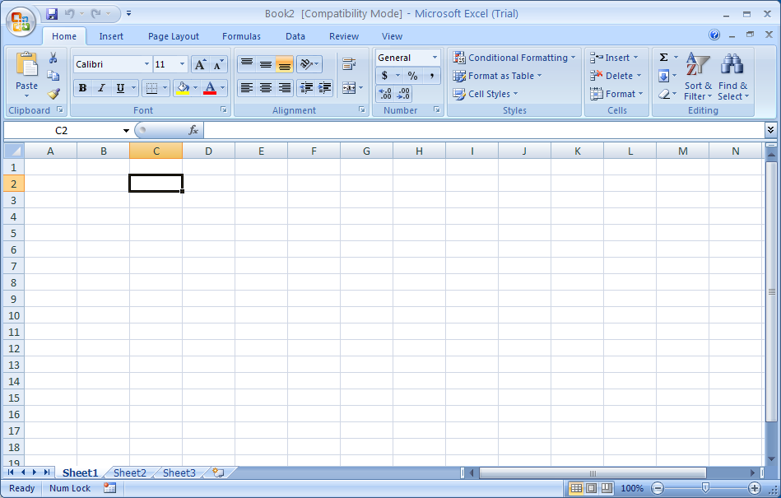

**Worksheet**

A worksheet is a collection of rows and columns. When a row and a column meet, they form a cell. Cells are used to record data. Each cell is uniquely identified using a cell address. Columns are usually labeled with letters while rows are usually numbers. Each cell can contain a number, text or formula. A cell can also reference another cell in the same worksheet, the same workbook or a different workbook. In Excel 2010, the maximum size of a worksheet is 1,048,576 rows by 16,384 columns.

**Workbook**

A workbook is an Excel file that contains one or more worksheets. Each of the workbook's worksheets is in separate tabs on the bottom of the Excel window. By default, a new Excel workbook will contain three worksheets. You can switch between worksheets by clicking on the worksheet's tab on the bottom of the Excel window

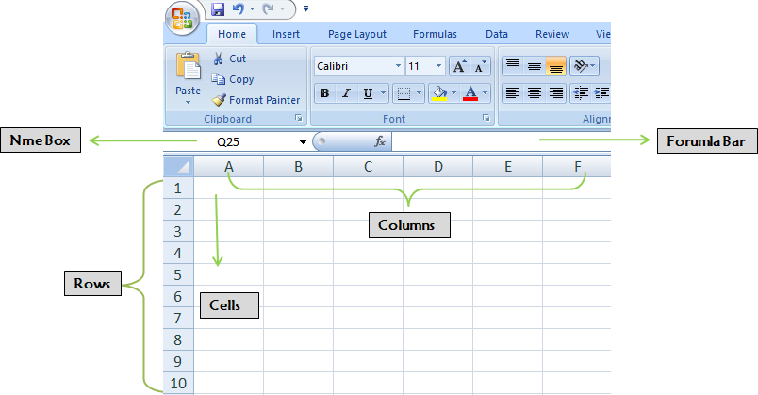

**Sheets**

A sheet is a single page that contains its own collection of cells to help you organize your data. There can be many sheets in your Excel document and you can see the sheets listed as tabs along the bottom of your document.

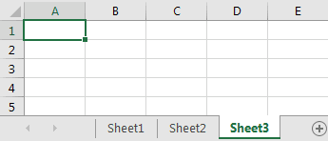

In this example, we have three sheets in our spreadsheet - Sheet1, Sheet2, and Sheet3.Each sheet has its own name and you can switch between the sheets by clicking on the name of the sheet you want to view. In the example above, we have selected Sheet3.

Traditionally when you create a new Excel document, three sheets (Sheet1, Sheet2, and Sheet3) are created in the spreadsheet and Excel automatically selects Sheet1.

**Cell**

In Microsoft Excel, a cell is a rectangular box that occurs at the intersection of avertical column and a horizontal row in a worksheet. Vertical columns are numbered with alphabetic values such as A, B, C. Horizontal rows are numbered with numeric values such as 1, 2, 3.

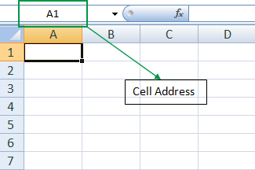

**FORMULAS**

It is simply a statement made up of operands‟ and operators‟ It helps to calculate and display results from data entered into its cells. Formulas can be simple arithmetical formulas or complicated formulas involving conditional statements and nested functions.

A formula always starts with an equal sign (=), which can be followed by numbers, math operators (like a + or - sign for addition or subtraction), and built-in Excel functions, which can really expand the power of a formula.

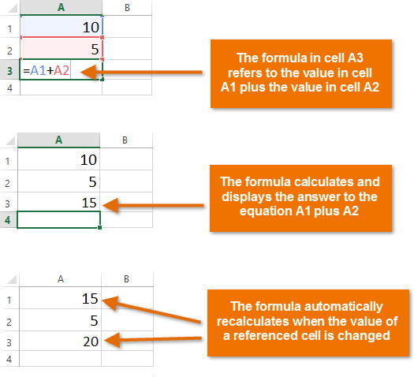

**MATHEMATICAL OPERATORS**

1. Addition
2. Subtraction
3. Multiplication
4. Division
5. Exponent

**Addition**:

* The simplest type of Excel addition formula is made up of the = sign, followed by two or more numbers, with the + operator in between them.
* For example, to add together the numbers 2, 7 and 1, type the following into any Excel cell: = 2 + 7 + 1(This returns the result 10)
* As with all Excel formulas, instead of typing the numbers directly into your addition formula, you can use references to cells containing numbers.
* The Excel addition formula in cell A1 of the spreadsheet on the right adds together the contents of cells B1, B2 and B3 (which contain the values 2, 7 and 1). Again, the formula returns the value 10

**Sum Function**

* The SUM function, one of the math and trig functions, adds values. You can add individual values, cell references or ranges or a mix of all three.

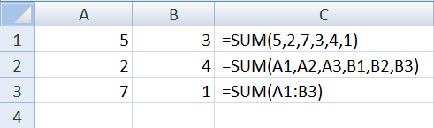

**Subtraction:**

* The simplest type of Excel subtraction formula consists of the = sign, followed by two or more numbers, with the - operator in between them.
* For example, to subtract the numbers 2 and 5 from 11, type the following into any Excel cell:

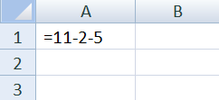

* As with all Excel formulas, instead of typing the numbers directly into your subtraction formula, you can use references to cells containing numbers.
* The Excel subtraction formula in cell A1 of the spreadsheet on the right subtracts the values in cells B2 and B3 (i.e. the values 2 and 5) from the value in cell B1 (i.e. the value 11).
* Again, the formula returns the value 4.

**Multiplication:**

* The simplest way to perform multiplication in Excel is to type in the = sign, followed by two or more numbers, separated by the * operator.
* For example, to multiply the numbers 4, 3 and 10, type the following into any Excel cell:
* An example of how perform multiplication in Excel, using cell references, is shown in cell A1 of the below spreadsheet. This formula multiplies the numbers in cells B1, B2 and B3 (i.e. the values 4, 3 and 10), and again, returns the value 120.

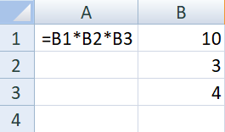

**BUILT IN FUNCTIONS**

Excel provides a large number of built-in functions that can be used to perform specific calculations or to return information about your spreadsheet data. These functions are organized into categories (text, logical, math, etc.).

The specific way in which a function is written is referred to as syntax. The syntax for a function is: An equal’s sign (=), the function name (SUM, for instance) and one or more arguments.

**Types of built-in functions**

1. Text Functions
2. Date & Time Functions
3. Statistical Function
4. Conditional Functions
5. Logical Functions
6. Mathematical Functions
7. Lookup Functions
8. Reference Functions